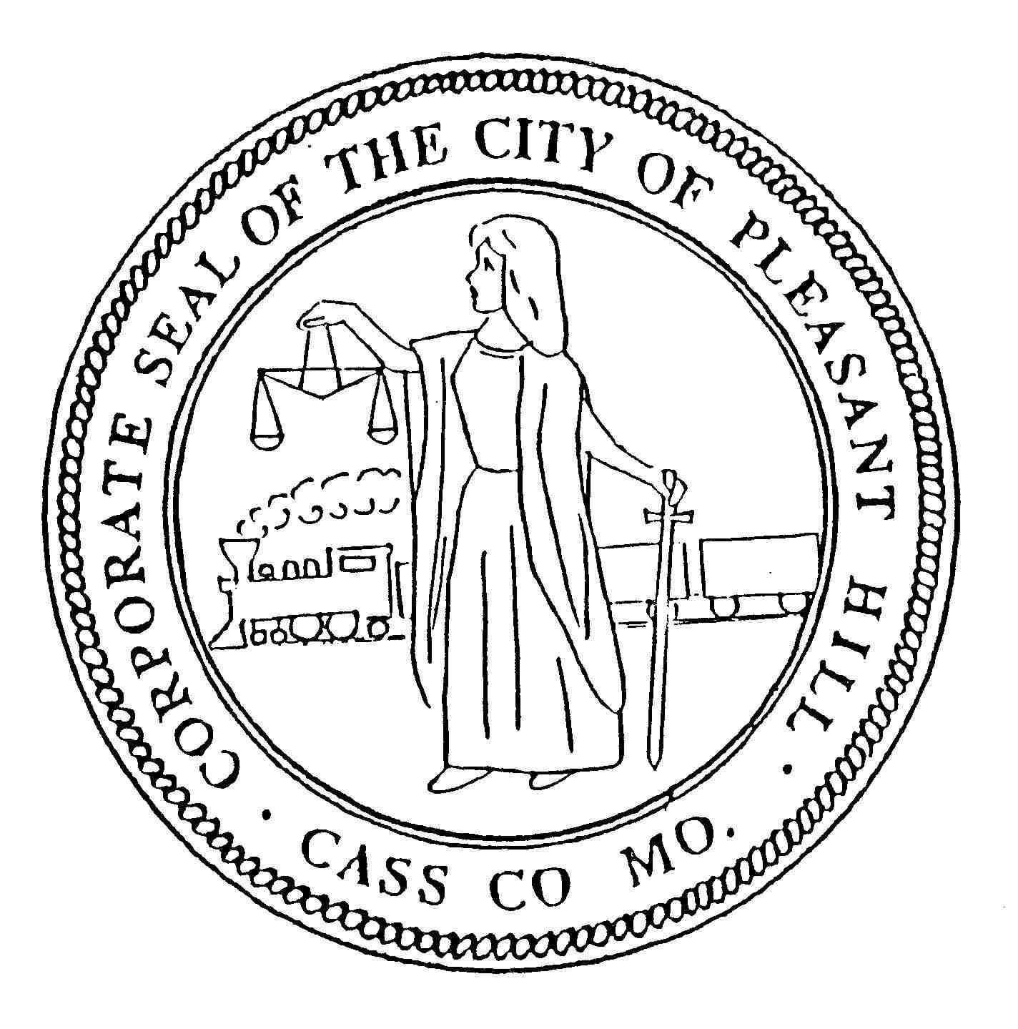

**City of Pleasant Hill**

203 Paul Street, Pleasant Hill, MO 64080 816-540-3135 / Fax: 816-987-5141

Planning & Zoning Commission Regular Meeting August 7, 2018 (Tuesday) 7:00 PM City Hall Conference Room.

The Historic Preservation Meeting scheduled for August 7, 2018 has been cancelled due the lack of agenda items. The next scheduled meeting will be September 4, 2018 (Tuesday) at 7 PM.